USER CREATION
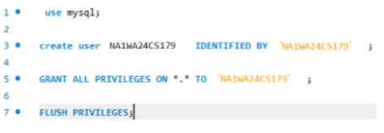
STUDENT DATABASE
Query 1: Creating tables
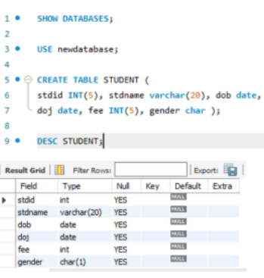

Query 2: Inserting values
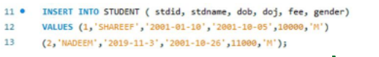

Query 3: Modifying values
